


ICTWEB432 Design website layouts

ICTWEB443 Implement search engine optimisations

ICTWEB450 Evaluate and select a web hosting service

ICTWEB444 Create responsive website layouts

Learner version

Front End Design & Development Assessment 2

Portfolio

Disclaimer: This resource was developed by Holmesglen Institute of TAFE in 2024 for the State of Victoria (Department of Education and Training) for educational purposes, is © State of Victoria (Department of Education and Training) and is available under a Creative Commons Attribution Non-commercial 4.0 International (CC BY-NC 4.0) license.
The license does not apply to: Trademarks or branding, including the Victorian Government logo and any unattributed content supplied by third parties




Learner version

Front End Design & Development Assessment 2

Portfolio

Learner information
Learner name: Van Minh Le | Learner ID: 100693330

Section A – Program/course details
Qualification code: ICT40120 | Qualification title:  Certificate IV in Information Technology (Web Development)  Certificate IV in Information Technology (Programming)
Unit code:  CWEB6 - Front End Design & Development  ICTWEB432  ICTWEB443  ICTWEB450  ICTWEB444 | Unit title:  Design website layouts  Implement search engine optimisations  Evaluate and select a web hosting service  Create responsive website layouts
Pre/co-requisites: N/A

Section B – Assessment task details
Assessment number: 2 of 2 | Semester/year: 1/2025 |  | Due date: Session 8
Duration of assessment: 10 hours |  | Assessment task results: This assessment task will be marked as:  ☒ Ungraded result: satisfactory or not yet satisfactory

Section C – Instructions to learners
Portfolio task
This assessment task requires learners to develop & deploy a website for a client using HTML5 and CSS3. The teacher will be playing the role of the client & user for this assessment task. This website will need to be designed, built, hosted and optimised.

This project has been divided into 8 key parts. Each part must be completed as per the instructions:

Part 1 – Determine Scope & Content Strategy
Part 2 – Website Layout Planning
Part 3 – Development of the Website
Part 4 – Development Environment & Testing (Milestone)
Part 5 – Production Environment & Deployment
Part 6 – SEO Research and Analysis
Part 7 – Optimising the Live Website
Part 8 – Client Sign Off

- This task is to be completed individually.
- Using this assessment document, please read all questions in this document and record your answers in the document against each question.
- To be satisfactory in this assessment task all answered questions must correctly meet the marking guide criteria.
- Discuss with your assessor if you feel you require special consideration or adjustment for this task.
- Learners can consult class learning material via Brightspace and other softcopy information, including information from the Internet. However, all answers must be in a learner’s own words. Where a quote is used the learner must cite the information source.
- This completed assessment task must be uploaded to Brightspace along with a complete and signed coversheet by the due date.
- You must submit all required working files, documentation, and any other assets that you feel may be required in a zipped file, including the completed and signed coversheet. The assessment must be completed and submitted electronically to Brightspace by the due date. If this is not possible, you must contact your assessor to gain written approval for an alternative arrangement for submitting the assessment.
- Learners must contribute to and abide by organisational standards including intellectual property and privacy.

REFER TO THE SUPPORTING DOCUMENTATION FOR FUTHER ASSESSMENT DETAILS

Section D – Conditions for assessment

Unit application:
- This is an individual task.
- You must meet all criteria listed in the marking guide to be satisfactory in this task.
- You must submit all required working files, documentation, and any other assets that you feel may be required in a zipped file, including the completed and signed coversheet. The assessment must be completed and submitted electronically to Brightspace by the due date. If this is not possible, you must contact your assessor to gain written approval for an alternative arrangement for submitting the assessment.
- If not successful within the enrolment period as per Holmesglen assessment procedure, you will be requested to resubmit within 7 days of receiving feedback. You will have the opportunity to resubmit if any part of the assessment is deemed unsatisfactory (you are permitted TWO (2) resubmission per assessment task). Resubmissions must be submitted by the resubmission due date provided by your teacher.
- This task is open book. You may use the internet for research purposes only. All answers must be in your own words. Where a quote is used, you must cite the information source.
- If you feel you require special allowance or adjustment to this task, please discuss with your assessor within one week of commencing this assessment. Any change to assessment arrangements must be reviewed by the Education Manager and approved by the Head of Department.
- You can appeal an assessment decision according to the Holmesglen Assessment Complaints and Appeals Procedure.
- You are expected to dedicate time to develop this assessment task both in and out of the classroom.
- Leaner must contribute to and abide by organisational standards including intellectual property, privacy laws, and plagiarism and academic honesty. Further information is detailed at: https://holmesglen.edu.au/Students/Student-Resources/

Equipment/resources learners must supply: | Equipment/resources to be provided by the RTO:
Learners opting to BYOD laptop or intending to learn remotely will require access to:  A MAC or PC/laptop with the following minimum specification:  • Quad-Core CPU, 16GB of RAM, 250GB of Storage, 2 GHz or faster processor  • Windows 10 OS, or virtual machine installed with Windows 10 OS (available free from https://developer.microsoft.com/en-us/windows/downloads/virtual-machines/ or https://www.microsoft.com/en-us/evalcenter/evaluate-windows-10-enterprise)  • Headset with microphone and webcam  • Internet access  Applications access available through Holmesglen MyHorizon and free access which can be downloaded via link below:  • Brightspace (Learning Management System) - https://holmesglen.brightspace.com/  • 365 Microsoft office suite - https://portal.office.com  • WebEx - https://holmesglen.webex.com/  • Holmesglen OneDrive  • Google Chrome – recommended web browser  • 7-Zip - https://www.7-zip.org/download.html  • Visual Studio Code - https://code.visualstudio.com/ | This is a blended learning course and as such a remote learner will access their own computer equipment as per the specification provided. The Institute will provide the following:  Data projector, whiteboard, computer with single screen per student (double screens preferred), computer with double screen for teacher, conference webcam managed by teacher.  Minimum MAC or computer specification:  • Quad-Core CPU, 16GB of RAM, 250GB of Storage, 4 GHz processor  • Internet access  Applications access available at ZENworks and Holmesglen MyHorizon:  • Brightspace (Learning Management System)  • 365 Microsoft office suite  • WebEx  • Google Chrome – recommended web browser  • 7Zip  • Visual Studio Code

Section E – Assessment questions/criteria
Assessment number: 2 |  | Assessment title: Portfolio
Unit code:  CWEB6 - Front End Design & Development  ICTWEB432  ICTWEB443  ICTWEB450  ICTWEB444 | Unit title:  Design website layouts  Implement search engine optimisations  Evaluate and select a web hosting service  Create responsive website layouts

PORTFOLIO TASK

Criteria for assessment | Satisfactory  Yes No |  | Comment
The following has been submitted for assessment:
Assessment Sheet (signed & fully completed) | ☐ | ☐
Portfolio website (zipped & to specifications) | ☐ | ☐
Marking Criteria (for each product document/s supplied):
Part 1 – Determine Scope & Content Strategy
Assessment Documentation
- The learner has briefly explained:  - the purpose of the website,  - at least THREE (3) web standards or guidelines relevant to the development of the website,  - at least ONE (1) legal requirement applicable to the build, AND  - at least ONE (1) web protocol relevant to the publishing of the website to the browser | ☐ | ☐
- The learner has listed THREE (3) pieces of information that the website must include/display | ☐ | ☐
- The learner has summarised at least THREE (3) features that the website must incorporate | ☐ | ☐
- The learner has confirmed at least TWO (2) development tools to build and test the website | ☐ | ☐
- The learner has confirmed:  - TWO (2) browsers,  - TWO (2) devices, and  - TWO (2) operating systems,  that will be compatible with the final website build. | ☐ | ☐
- The learner has listed THREE (3) potential users of the website | ☐ | ☐
- The learner has developed at least TWO (2) fictional “user personas”, and for each persona, has stated their fictional name, age, occupation, motivations for visiting the client business and ONE (1) feature they would use on the website | ☐ | ☐
- The learner has identified at least THREE (3) areas of UX focus for the upcoming website build | ☐ | ☐
- The learner has confirmed THREE (3) pages to be built for the website build | ☐ | ☐
- The learner has identified the required user content, operating system and website features as specified by the brief & planned user analysis | ☐ | ☐
- The learner has consulted with the client and confirmed the required pages, features, sections and information needed for the website | ☐ | ☐
Part 2 – Website Layout Planning
Assessment Documentation
- The learner has listed at least TWO (2) modern web design principles to improve overall user experience | ☐ | ☐
- The learner has listed at least FOUR (4) important UI design needs for the website. | ☐ | ☐
- The learner has developed ONE (1) visual sitemap of the website – to confirm its’ required pages and expected content flow. | ☐ | ☐
- The learner has created THREE (3) website wireframes for the Home Page and TWO other pages of the website, to demonstrate its’ page hierarchy and structure. | ☐ | ☐
- The learner has designed the website layout using applicable tools and procedures according to client requirements | ☐ | ☐
- The learner has completed and documented the design structure for their planned website build | ☐ | ☐
- The learner has acted as client liaison during milestone sign off and obtained useful feedback required to finalise their content and design planning | ☐ | ☐
Part 3 – Development of the Website
Assessment Documentation
- The website has a home page & TWO (2) additional pages, being THREE (3) pages in total. | ☐ | ☐
- The website contains at least THREE (3) completed webpages that conform with the planned website designs. | ☐ | ☐
- The website has structured its webpage sections using a mixture of semantic markup elements. | ☐ | ☐
- The learner has incorporated the UI design needs into the website, as detailed in Part 2 Question 2 | ☐ | ☐
- An external CSS stylesheet has been developed and populated with CSS and linked correctly to each webpage. | ☐ | ☐
- The website has been themed with at least three core colours: primary, complementary and branding. | ☐ | ☐
- At least ONE (1) UI/component can scale to a mobile-device viewport size using the media declaration | ☐ | ☐
- The website has at least ONE (1) more section/component that is responsive to mobile-device sizes, through using any of flexbox, grid, a responsive framework or responsive units.  The learner has also demonstrated understanding of frameworks and libraries. | ☐ | ☐
- The learner has built the website structure, and each of its’ webpages, to meet the client’s content and design requirements | ☐ | ☐
- The learner has styled their website in a manner which is consistent with their design specifications in Part 2 | ☐ | ☐
Part 4 – Development Environment & Testing
Assessment Documentation
- The learner has validated the HTML of the website & recorded the results, for at least ONE (1) webpage, in accordance with the W3C HTML Validator. | ☐ | ☐
- The learner has validated the CSS of the website & recorded the results, for at least ONE (1) webpage, in accordance with the W3C CSS Validator. | ☐ | ☐
- The learner has determined an acceptable performance time budget for their website to load all content within, for a user accessing your site for the first time. | ☐ | ☐
- The learner has determined the technical performance measurements for the website using Google Lighthouse | ☐ | ☐
- The learner has commented on the performance of the website and provided ONE (1) example of how a web developer could improve the performance of their website | ☐ | ☐
- The learner has tested the HTML of the website in TWO (2) different browsers, recorded the results and made any necessary corrections where functional problems occurred | ☐ | ☐
- The learner has designed & conducted four tests for their website’s functionality & layout – with each test providing the (i) test conducted, (ii) the expected output of the test, (iii) success or failure outcome, and (iv) comments on test result and debugging, as follows:  - That the website is functional for users, in at least TWO (2) browsers and TWO (2) devices, being desktop AND mobile;  - That the website is secure according to cybersecurity procedures and protocols;  - That the website has included UI for learner’s Design Need 1 and it functions as required; and  - That the website has included UI for learner’s Design Need 2 and it functions as required. | ☐ | ☐
- The learner has defined and carried out UI & UX tests on their website & has amended their website layout where necessary, with all necessary supporting documentation | ☐ | ☐
- The learner has built a website that is validated, performant and functional for a variety of browsers and device sizes | ☐ | ☐
- The learner has sought client confirmation, obtained milestone feedback & has signed off the development build stage for their website | ☐ | ☐
Part 5 – Production Environment & Deployment
Assessment Documentation
- The learner has listed at least THREE (3) services/features that are required by the web host, to be selected | ☐ | ☐
- The learner has reviewed the characteristics of different hosting services and has assessed compatibility with business and client needs, including:  - the cost of webhosting;  - what type of web hosting it provides (e.g. shared server, cloud server, VPS, etc.);  - languages the host supports;  - the amount of storage space provided with the selected plan;  - if SSL certificate and/or domain options are included;  - at least ONE (1) additional server application that may be useful to the client. | ☐ | ☐
- The learner has reviewed and confirmed email services available in order to be compliant with client business needs. | ☐ | ☐
- The learner has selected and confirmed the web host solution to be used with the website launch | ☐ | ☐
- The learner has created the required online web host account to host the website. | ☐ | ☐
- The learner has confirmed the public URL of their hosted website, to confirm the successful launch. | ☐ | ☐
- The learner has correctly verified the website domain and indexing, using Google Search Console & Google Search. | ☐ | ☐
- The learner has confirmed the integration of Google Analytics into the website & shown traffic reports | ☐ | ☐
- The learner has evaluated their website launch’s reports including Google Search rankings, traffic numbers and areas for improvement of performance. | ☐ | ☐
- The learner has demonstrated that the web host has reporting systems in place to monitor website performance/uptime | ☐ | ☐
- The learner has confirmed that the web host’s server environment supports the required features and technologies needed to run the client website | ☐ | ☐
- The learner has discussed the extent the web host supports dynamic features such as PHP, MySQL and/or WordPress support, and how these align with the web build’s required technologies. | ☐ | ☐
- The learner has confirmed support services perform adequately by outlining community/customer feedback and testimonials on the service | ☐ | ☐
- The learner has discussed competing web hosting services with the client & evaluated a single provider that aligns with client selection criteria and business needs | ☐ | ☐
- The learner has successfully launched their website on their chosen web hosting platform & recorded initial performance/traffic results /traffic results | ☐ | ☐
Part 6 – SEO Research and Analysis
Assessment Documentation & Working Files
- The learner has prepared a client recommendation report covering search engine optimisation, search engine marketing and social network marketing | ☐ | ☐
- The learner has developed an action and timeframe including goals, recommendations, priorities, schedules and allocation of roles & responsibility | ☐ | ☐
- The learner clearly and succinctly summarised & presented their SEO recommendations report and subsequent action plan, covering all necessary goals, recommendations, priorities, schedules and allocation of roles & responsibility with regard to search engine optimisation, search engine marketing and social network marketing. | ☐ | ☐
Part 7 – Optimising the Live Website
Assessment Documentation
- The learner has created a keyword suggestion list through various methods, including short and long tail keyword suggestions | ☐ | ☐
- The learner has identified three SEO optimisation opportunities, based on website gaps and has outlined implementation strategies for long and short tail keywords and content sections. | ☐ | ☐
- The learner has confirmed that the website has incorporated the FIRST SEO opportunity listed in Question 1(b) above. | ☐ | ☐
- The learner has confirmed that the website has incorporated the SECOND SEO opportunity listed in Question 1(b) above. | ☐ | ☐
- The learner has confirmed that the website has incorporated the THIRD SEO opportunity listed in Question 1(b) above. | ☐ | ☐
- The learner has implemented a back link for their website in order to improve SEO rankings further, via the “The Live Café Dashboard”. | ☐ | ☐
- The learner has conducted, recorded and reviewed their previous SEO results and compared it in relation to a new round of SEO testing, including your initial SEO position in Part 5, Questions 7 & 8.  - a “site:” website search;  - a “keyword” search, using one of the implemented keywords; and  - An updated Google Analytics over-time traffic test for at LEAST THREE (3) elapsed days | ☐ | ☐
- The learner has evaluated and summarised the updated SEO’s performance, whether performance improved and identified other opportunities for improvement. | ☐ | ☐
- The learner has repeated their Google Lighthouse test and commented on the technical performance of the website, and how it compares to their performance budget. | ☐ | ☐
- The learner has conducted a comprehensive analysis of the websites SEO performance, provided optimisation suggestions and implemented changes to improve previous performance | ☐ | ☐
- The learner confirms that the hosting of the website on the selected web host is performing within client technical and security benchmarks | ☐ | ☐
Part 8 – Client Sign Off
Assessment Documentation
- The learner has completed the Milestone – Parts 1 to 4, Development Build | ☐ | ☐
- The learner has completed the Final Build – Parts 5 to 8, Deployment & DevOps | ☐ | ☐
- The project meets all applicable web standards & has been tested, debugged and documented according to user requirements and expected outcomes | ☐ | ☐
- The learner has analysed & benchmarked search, hosting and technical performance of the website in line with meet client requirements | ☐ | ☐
- The learner has obtained sign off from the client and confirmed business requirements are met | ☐ | ☐

Learner Acknowledgement and Cover Sheet
Academic Declaration:
By submitting this assessment task and signing the below, I acknowledge and agree that:
- This completed assessment task is my own work.
- I understand the serious nature of plagiarism and I am aware of the penalties that exist for breaching this.
- I have kept a copy of this assessment task.
- The assessor may provide a copy of this assessment task to another member of the Institute for validation and/or benchmarking purposes.
- For electronic submissions, by typing your name in the student signature field, you are accepting this declaration.
Learner name: Van Minh Le | Learner ID: 100693330
Submission Date: Insert date
Learner signature: Van Minh Le

Section F – Feedback to Learner
Has the learner successfully completed this assessment task? Yes ☐ No ☐
Assessor feedback (as appropriate): Insert feedback
Resubmission allowed: Yes ☐ No ☐ Resubmission due date: Insert date
Assessor name: Insert name
Assessor signature:

Project Brief
Read through the brief below take note of the needs and requirements outlined in the brief.
Introduction
This assessment task requires learners to develop & deploy a website for a client using HTML5 and CSS3. The teacher will be playing the role of the client & user for this assessment task. This website will need to be designed, built, hosted and optimised.

This project has been divided into 8 key parts. Each part must be completed as per the instructions:

Part 1 – Determine Scope & Content Strategy
Part 2 – Website Layout Planning
Part 3 – Development of the Website
Part 4 – Development Environment & Testing (Milestone)
Part 5 – Production Environment & Deployment
Part 6 – SEO Research and Analysis
Part 7 – Optimising the Live Website
Part 8 – Client Sign Off

Client Brief Scenario – “Local Café”
As a freelance web developer, you have recently been engaged by a café in the Moorabbin area – who seeks to establish an online presence for their café, in the local area and drive customers and users to the site & café, as well as improve overall brand engagement.

Your task is to design and develop a three-page website for this local café. The café, known as "Local Café", is a popular spot in the community known for its cosy atmosphere and delicious coffee. The website should reflect the café's warm and welcoming vibe, while providing all the necessary information for potential customers.

During your meeting with the client, they emphasised the following:

~ “I want a website that is visually appealing, easy to navigate, and works well on a variety of devices. Our customers come from a wide array of backgrounds, like coffee enthusiasts, locals, tourists, and students/professionals. So, as a result, the website needs to be compatible with various operating systems including Windows, macOS, iOS, and Android and it should also be accessible on various browsers. ~

General Website Requirements
- Home Page and at least TWO (2) additional pages, being THREE (3) pages in total.
- Original and consistent website colour scheme and style (distinct from exemplar).
- Attempt to maintain a design methodology that is modern, simple, mimics trending website layouts and is largely responsive.
- Fonts must be suitable for web design: web safe, local and/or google fonts.
- Development environment to build your website must be Visual Studio Code IDE (“code editor”).
- Browser support: At least Chrome, Edge & Firefox.

Website Scope & Functionality
- Required Content – the website should have a cosy and welcoming design that reflects the café's atmosphere and should include information about:
  - the café,
  - the menu,
  - opening hours,
  - location, and
  - contact details.
- Required Functionality – the website needs to be designed to provide a seamless and enjoyable user experience and needs to include features like:
  - a readable/downloadable menu,
  - location map, and
  - a contact form.
- Required Useability – the website needs to capture a wide audience of customers and cater to a wide array of access requirements, by adhering to best practices for:
  - Responsive design,
  - Good web hosting performance, and
  - SEO principles.

Hosting Requirements
- Reliable hosting: Their website needs to load reliably & retain good load time performance
- Cost: As low as possible to a maximum of $50 per month
- Ease of use: A user-friendly control panel is preferred as they may not have extensive technical experience
- Storage: At least 100mb of storage
- Ideal options: Ideally options for Secure Sockets Layer (SSL) certificate for secure data transmission, but not mandatory.
- Email Requirements: Moderate email usage – they would need email accounts for a few team members, with enough storage for sending and receiving basic business documents. These can be part of the web host, or externally hosted.

Design Specifications
- Consistency: The design of the website should be consistent in terms of fonts, colours, and layout to provide a seamless user experience.
- Usability: The website should be easy to navigate and intuitive to use.
- Simplicity: The design should be clean and simple, making it easy for users to find the information they need.
- Visibility: Important elements should be easily visible to guide users to the desired information or action.
- Responsiveness: The website should be designed to provide an optimal viewing experience across a wide range of devices, from desktop computers to mobile phones.

Technical Standards, Accessibility Guidelines & Business Requirements
- HTML5 & CSS3 standards & modules are to be used to develop page structure, layout and design.
- Ensure correct use of HTML semantics & appropriate content flow, in accordance with W3C standards.
- Website to incorporate examples of accessible web content, in accordance with web accessibility guidelines and standards (including WCAG, WAI-ARIA, UAAG, ATAG).
- Only Bootstrap may be used as the responsive frameworks / library (not compulsory)
- Web protocols to be followed including HTTP & HTTPS
- No requirement for JavaScript or scripting language.
- Sourced user data, assets, icons & images must be used in accordance with attributed copyright and privacy laws as per the Copyright Act 1968 (Cth) and Privacy Act 1988 (Cth) respectively.

Part 1 – Determine Scope & Content Strategy
Assessment Documentation

Content Planning
As discussed in our lectures, prior to coding the website – it is critical to consider:
- the purpose and scope of the website we are building;
- the required features set by the client; and
- the different users we wish to attract.

Complete the following questions, which are broadly grouped into two major sections: (1) Review of the Client Brief, and (2) Conducting a User Analysis.

Question / Criteria |  |  | Answer/satisfactory response
WEBSITE SCOPE
For the questions below, you will read & review the client brief to determine the broad website strategy. These points will then inform what users you intend to target, the UI you need to build, and how you wish to design the UX for Part 2!

Note – you will likely need to copy/paraphrase parts of the brief to form part of your answers below:
- Briefly explain, in at least ONE (1) paragraph each:  - the purpose of the website,  - at least THREE (3) web standards or guidelines relevant to the development of the website,  - at least ONE (1) legal requirement applicable to the build, AND  - at least ONE (1) web protocol relevant to the publishing of the website to the browser |  |  | a. Purpose of website
 |  |  | The website focuses on promote the Local Café in Moorabbin. It should be visually appealing, easy to navigate and works well on a variety of devices. It helps the local café’s customers including coffee enthusiasts, local residents, tourists, and students or professionals easily find and connect with the café shop.
 |  |  | b. Web standards / guidelines (3)
- HTML 5 and CSS 3 standards
- WCAG (Web Content Accessibility Guidelines): It helps making the website accessible to people with disabilities.
- WAI-ARIA (Web Accessibility Initiative - Accessible Rich Internet Applications): It supports screen reader users with proper roles and attributes for interactive elements.
 |  |  | c. Legal Requirements (1)
 |  |  | - The Copyright Act 1968 (Cth) and the Privacy Act 1988 (Cth) require that all sourced user data, assets, icons & images used on the website must be original or properly licensed in accordance with attributed copyright and privacy laws.
 |  |  | c. Web Protocol (1)
 |  |  | - The HTTPS protocol ensures secure data transmission between the user’s browser and the website, protecting sensitive information such as contact form entries.
- List THREE (3) pieces of text OR media content that the website must include/display as part of the required scope |  |  | - The café’s menu: It is displayed on the site or provided as a downloadable file.  - Location map: The website includes an embedded location map to show where the café is located.  - Contact details: It is contact form including the café customers' phone number, email and a text area where customers can write their content requirements.
- Summarise and list at least THREE (3) static or interactable features that the website must incorporate |  |  | - A readable or downloadable Menu: It allows users to view or download the café’s menu as a file.  - A Contact Form: It is a form where users can enter customer information to contact the café.  - Local map: It is perhaps a Google map to shows the café’s location and allows users to get directions.
- Confirm at least TWO (2) development tools required to build & test the website |  |  | - Development environment to build your website must be Visual Studio Code IDE (“code editor”).  - Test Browser: At least Chrome, Edge & Firefox.
- Confirm which:  - TWO (2) browsers,  - TWO (2) devices, and  - TWO (2) operating systems,  will be compatible with your final website build. |  |  | Compatible Browsers (2)
- Google Chrome
- Mozilla Firefox
 |  |  | Compatible devices (2)
- Desktop computer
- Smartphone
 |  |  | Compatible operating systems (2)
- Windows
- Android (IOS)
CONTENT STRATEGY
Below – you will now formulate how to plan out your website based on user needs and their planned desired user experience:
- List THREE (3) potential users of the website (e.g. students, researchers, doctors, etc.) |  |  | - Local residents  - Tourists  - Students and Professionals
- Based on your determined users in (a), develop at least TWO (2) fictional “user personas” – designed to simulate the different types of users who will visit your website.  For each persona, state their fictional:  - name  - age  - occupation  - motivations for visiting the client business  - ONE (1) feature they would use on the website  Example for Bookstore: “John, a 28-year-old tourist who's visiting the area. He's looking for a local, quiet bookstore to find books in his native language to read, while travelling. He accesses bookstore websites on his phone, to find the location, opening hours and contact details” |  |  | Persona One
 |  |  | Persona 1 – [Minh, Student]: Minh, a 30 years old student. He is looking for a cozy and quiet place to have a coffee, and take breaks during her long study sessions. He prefers places with free Wi-Fi and a comfortable atmosphere. He would use the contact form to inquire about Wi-Fi availability.
 |  |  | Persona Two
 |  |  | Persona 2 – [Tom, Officer staff]: Tom, 45 years old office staff. He visits the café during his lunch break to grab a quick coffee and relax. He wants to quickly service and appreciates knowing the café’s menu and opening hours in advance. Tom would use the menu page to view the available food and drink options before visiting.
- Based on the planned user analysis above, identify at least THREE (3) areas of UX focus for the upcoming website build  Example for Bookstore: ‘Website needs to include a location map & easy-to-find/CTA for the contact details’ |  |  | - Responsive design for mobile users: It ensures the website looks good and works well on smartphones for users.  - The website should be easily access menu and opening hours. It should display key information like the café’s menu and business hours clearly on the homepage.  - Location map and contact form should be perhaps the Google Map and a simple contact form to users easily finding and contacting to the café.
- With the confirmation of your website scope & content strategy, confirm what THREE (3) pages you will build for your website |  |  | - Home Page: It introduces the café, highlights its cozy vibe, and gives quick access to opening hours information.  - Menu Page: It should be the readable menu with an option to download it as a file.  - Contact Page: includes a contact form, embedded Google Map for the café location, and all necessary contact information.
Sign Off
Assessment Documentation
You will need to organise with your facilitator to observe your presentation and demonstrate the following skills:
Skills to be observed during this task to the required standard.  Checklist (To be completed by the learner’s facilitator)  The following tasks are to be completed in relation to Part 1 – Determine Scope & Content Strategy. Each of the skills must be observed on at least one occasion by the facilitator. |  |  |  |  |  | Satisfactory
 |  |  |  |  |  | Yes | No
- The learner has identified the required user content, operating system and website features as specified by the brief & planned user analysis |  |  |  |  |  | ☐ | ☐
- The learner has consulted with the client and confirmed the required pages, features, sections and information needed for the website |  |  |  |  |  | ☐ | ☐
Assessor Name | Alex Bicknell | Assessor Signature |  | Signature | Date | Insert Date

Part 2 – Website Layout Planning
Assessment Documentation

Design Planning
Once we understand our development restrictions & required content, we can begin sketching/mapping out how our website will look. It is always important to draft up items such as expected content flow (sitemaps), wireframes, style guides & prototypes.

Question / Criteria |  |  | Answer/satisfactory response
- List at least THREE (3) modern web design principles that your website will focus on, to improve overall user experience  The first dot point has been provided for you – complete the remaining TWO (2) design principles. |  |  | KEY WEB DESIGN PRINCIPLES  - Provided Example – Wide Useability (need to provide accessibility, useability and responsiveness)  - Consistent Design: It must be used consistent fonts, colours, and layout across all pages to create a professional user experience.  - Easily Navigation: Should create simple navigation bar structure so users can easily find information such as the menu, location information, and contact page.
- Confirm at least FOUR (4) Core UI Components that must be built for this website.  You should list each Core UI Component as a separate dot point and provide a brief explanation as to what it needs to be satisfied in your build.  The first dot point has been provided for you – complete the remaining THREE (3) design needs. |  |  | CORE UI COMPONENTS NEEDED  - Provided Example – CTA on Home Page: The website should include a “Call to Action” button, in the navbar, on the homepage that directs user attention to visit either the Menu or Contact page (depending on dev preference)  - Navigation Bar: A fixed or sticky navigation bar at the top of every page. It can include Home, Menu, and Contact page link. It should be responsive and easy to use on both desktop and mobile devices.  - Local map: The Contact page should be embedded a Google Map showing the café’s location to help users find the café easily.  - Contact Form: The Contact page should be had simple form where users can enter their name, email, and message to get in touch with the café. It should be clear, accessible, and easy to use.
- Based on your user content requirements in Part 1, develop ONE (1) visual sitemap of your website – to confirm its’ required pages and expected content flow.  Important reminder |  |  | 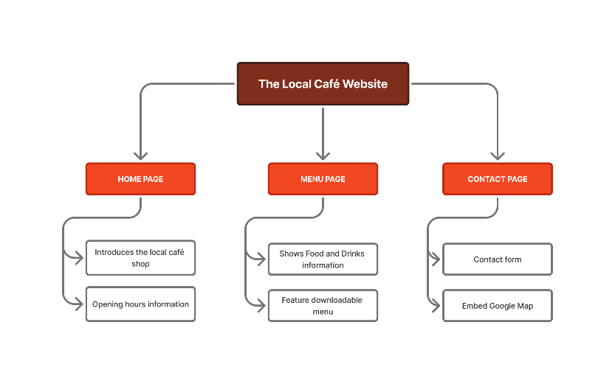
- Create THREE (3) website wireframes for the Home Page and TWO other pages of your website, to demonstrate its’ page hierarchy and structure.  Important reminder: A wireframe should be a visual representation of what the webpage will look like, highlighting key features such as navbar, header section, main article section(s) and the footer. Wireframes generally are done in greyscale with no colour. |  |  | HomePage  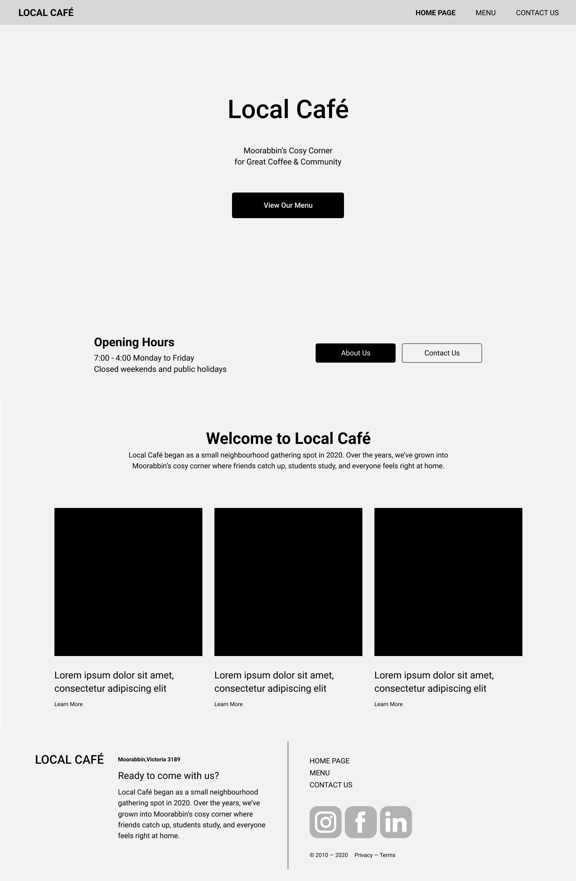  Menu Page  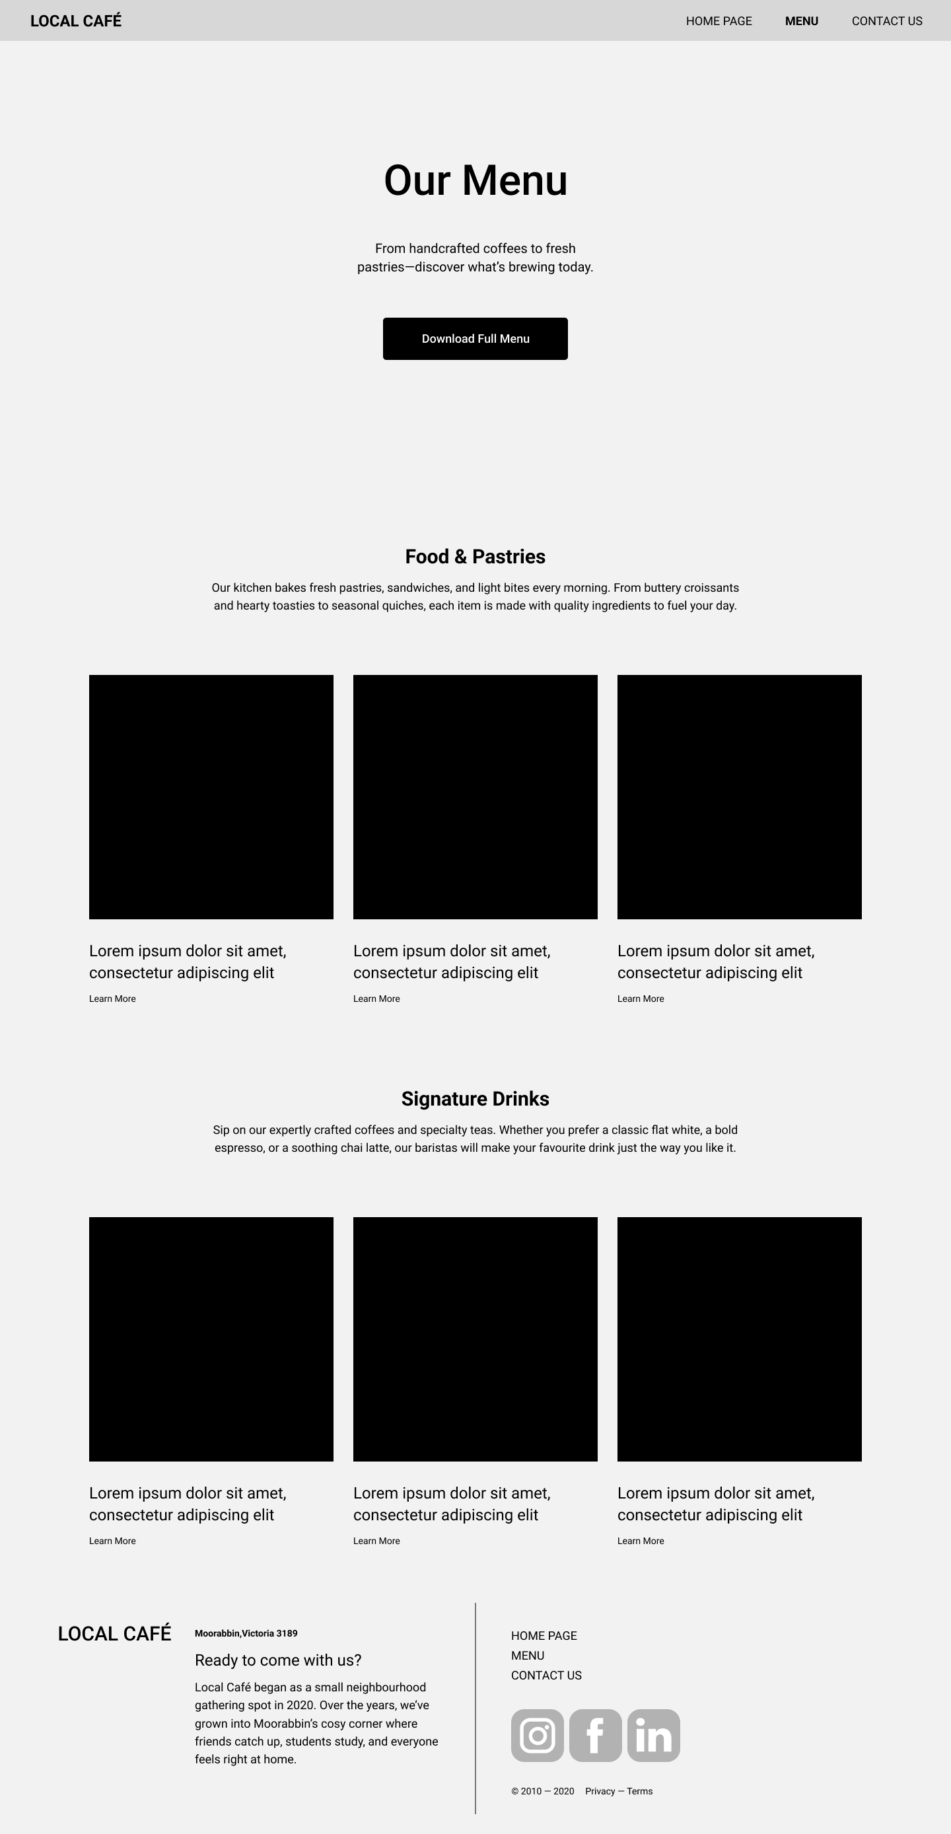  Contact Us page  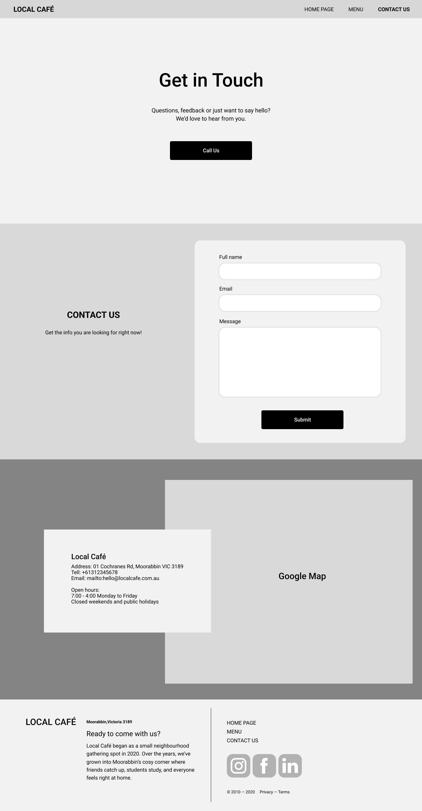
Sign Off
Assessment Documentation
You will need to organise with your facilitator to observe your presentation and demonstrate the following skills:
Skills to be observed during this task to the required standard.  Checklist (To be completed by the learner’s facilitator)  The following tasks are to be completed in relation to Part 2 – Website Layout Planning. Each of the skills must be observed on at least one occasion by the facilitator. |  |  |  |  |  | Satisfactory
 |  |  |  |  |  | Yes | No
- The learner has designed the website layout using applicable tools and procedures according to client requirements |  |  |  |  |  | ☐ | ☐
- The learner has completed and documented the design structure for their planned website build |  |  |  |  |  | ☐ | ☐
- The learner has acted as client liaison during milestone sign off and obtained useful feedback required to finalise their content and design planning |  |  |  |  |  | ☐ | ☐
Assessor Name | Alex Bicknell | Assessor Signature |  | Signature | Date | Insert Date

Part 3 – Development of the Website
Assessment Documentation

Website Build Time!
It is now time to begin developing your website! Ensure your design aligns with client requirements as outlined in Parts 1 and 2. Further, important tips to consider whilst building the website for your client include:
- ensure design consistency between pages, using same/similar fonts, consistent spacing and complementary colours;
- ensure each page is accessible by the user; and, most importantly
- ensure you meet the brief requirements by ticking off & providing relevant screenshots for the questions below.
Question / Criteria | Complete / Not Complete | Evidence of Completion
WEBSITE LAYOUT CHECKLIST
Create and define the structure of the website’s layout using the specified markup language, in accordance with brief requirements, as follows:
- The website has a home page & TWO (2) additional pages, being THREE (3) pages in total.  Insert ONE (1) screenshot of these three .html files, in your IDE, to show the names of the required webpages. | ☐ | < Insert code screenshot of IDE .html webpage files >
- The website contains at least THREE (3) completed webpages that conform with the planned website designs.  Insert THREE (3) screenshots of each of these webpages, that compare directly with three wireframes in Part 2, Question 4. | ☐ | < Insert THREE (3) screenshots of your three webpages like your wireframes >
- The website has structured its webpage sections using a mixture of semantic markup elements.  Insert ONE (1) screenshot of your code, that shows the use of at least ONE semantic element. | ☐ | < Insert code screenshot example of semantic elements>
- In Part 2 Question 2, you suggested a list of Core UI Components that your website would incorporate when building.  Provide ONE (1) screenshot for each for THREE (3) of the Core UI Components that demonstrates that requirements have been completed.  (THREE (3) screenshots in total) | ☐ | Implemented Core UI Component 1
 |  | < Insert ONE (1) screenshot of your webpage displaying the Core UI Component need >
 |  | Implemented Core UI Component 2
 |  | < Insert ONE (1) screenshot of your webpage displaying the Core UI Component need >
 |  | Implemented Core UI Component 3
 |  | < Insert ONE (1) screenshot of your webpage displaying the Core UI Component need >
WEBSITE STYLING CHECKLIST
Confirm the styling, formatting and layout of the webpages have been implemented using CSS, in accordance with brief requirements, as follows:
- An external CSS stylesheet has been developed and populated with CSS and linked correctly to each webpage.  Insert ONE (1) screenshot of an HTML webpage, with the link element that references your external CSS stylesheet. | ☐ | < Insert code screenshot of CSS link element >
- The website has been themed with at least three core colours: primary, complementary and branding.  State the hexcode of at least THREE (3) colours that make up your website theme, according to its priority. | ☐ | Primary Colour (70% of website)
 |  | < Record your hexcode here >
 |  | Complementary Colour (25% of website)
 |  | < Record your hexcode here >
 |  | Branding Colour (5% of website)
 |  | < Record your hexcode here >
- At least ONE (1) UI/component can scale to a mobile-device viewport (such as iPhone 12) size using media queries and/or responsive frameworks.  Insert ONE (1) screenshot of each:  - the media declaration (in HTML or CSS) creating the responsive component; and  - the webpage, in mobile-device mode, that displays the responsive component | ☐ | < Insert code screenshot of media declaration >  < Insert ONE (1) screenshot of your webpage in mobile-device mode >
- The website has at least ONE (1) more section/component that is responsive to mobile-device sizes, through using any of the following:  - CSS Flexbox  - CSS Grid  - Responsive Framework  - CSS responsive units  For this question:  - State ONE (1) example of a responsive framework/library;  - Confirm which technique was applied; and  - Insert ONE (1) screenshot of either the code declared OR the displayed responsive component | ☐ | - Responsive framework: < State example here >  - CSS Technique Used: < Confirm technique used >  < Insert ONE (1) screenshot of code declaration OR your webpage’s responsive component >
Sign Off
Assessment Documentation
You will need to organise with your facilitator to observe your presentation and demonstrate the following skills:
Skills to be observed during this task to the required standard.  Checklist (To be completed by the learner’s facilitator)  The following tasks are to be completed in relation to Part 3 – Development of the Website. Each of the skills must be observed on at least one occasion by the facilitator. |  |  |  |  | Satisfactory
 |  |  |  |  | Yes | No
- The learner has built the website structure, and each of its’ webpages, to meet the client’s content and design requirements |  |  |  |  | ☐ | ☐
- The learner has styled their website in a manner which is consistent with their design specifications in Part 2 |  |  |  |  | ☐ | ☐
Assessor Name | Alex Bicknell | Assessor Signature | Signature | Date | Insert Date

Part 4 – Development Environment & Testing
Assessment Documentation

Finalising the Initial Build
Congratulations on completing the initial build of your website!
However, for web developers, our job is not complete on completing the first cut – we need to ensure the website meets the general needs of users and adheres to HTML & CSS standards, as well as being free from bugs and UI glitches.

The following sections are to be completed to ensure that our website is ready for deployment!

MILESTONE: The very best developers will always ensure their site is functional & meets client’s expectations before launching the website. You are no different – and before you can progress to Part 5, you MUST sign off the above Parts 1 to 4 with “the client”.

MILESTONE DEADLINE: End of Session 5
Question / Criteria | Complete / Not Complete | Evidence of Completion
VALIDATION
The learner has validated the website against defined HTML and CSS standards & parameters:
- The learner has validated the HTML of the website & recorded the results, for at least ONE (1) webpage, in accordance with the W3C HTML Validator | ☐ | < Insert screenshot of HTML validation result >
- The learner has validated the CSS of the website & recorded the results, for at least ONE (1) webpage, in accordance with the W3C CSS Validator | ☐ | < Insert screenshot of CSS validation result >
PERFORMANCE:
The learner has measured the technical performance of the website, using in-browser automated testing tools:
- Determine an acceptable performance time (in seconds) for your website to load all content within - for a user accessing your site for the first time.  State a performance budget for your website, in seconds. |  | < Confirm estimated performance budget for website in seconds >
- Using Google Lighthouse in the Google Chrome DevTools, determine your technical performance measurements for your website.  Insert ONE (1) screenshot of the Google Lighthouse output in desktop and state your value for “Speed Index”.  Note: “Speed Index” determines how quickly content is visually displayed during page load | ☐ | < Insert screenshot of Google Lighthouse output >  - < Confirm speed index output >
- Briefly comment on the performance of your site and provide ONE (1) example of how a web developer could improve the performance of their website | ☐ | Comments on Website Performance
 |  | < Record your response here >
 |  | How to Improve Website Performance
 |  | < Record your answer here >
FUNCTIONALITY:
The learner has designed and implemented test cases against the website, to ensure the webpages reflect end user specifications:
- Test the HTML of the website in TWO (2) different browsers. Record the results and any necessary corrections made where functional problems occurred.  You must include at minimum ONE (1) screenshot for each browser displaying the website & label which browsers were used. | ☐ | Corrections Required?
< Record your response here >
(if no corrections, state “no corrections required”)
 |  | Successful Browser Tests (x2)
 |  | < Insert BOTH screenshots of the website in TWO browsers AND state which browsers>
- Test your website’s functionality & layout for any issues or errors & which require debugging.

Below you will need to design & complete at least FOUR (4) tests, each providing the (i) test conducted, (ii) expected output of the test, (iii) success / failure and (iv) comments on test result and debugging.

Template tests that could be conducted have been provided, as examples – BUT you will need to MODIFY some of these to match your UI design needs:
Test Design | Expected Output | Correct Function |  | Comment on Test
 |  | Yes | No
a. Test: That the website is functional for users, in at least TWO (2) browsers and TWO (2) devices, being desktop AND mobile | Expect the website to render correctly on two browsers, like Chrome and Edge, and two devices of desktop and mobile. | ☐ | ☐ | Refer to above Question 6 for Browser Test  < Insert TWO (2) screenshots of the webpage displayed in desktop mode AND in mobile mode >
b. Test: That the website is secure according to cybersecurity procedures and protocols. | Expect the website performs correctly and securely according to client requirements | ☐ | ☐ | < List at least ONE (1) feature you have enacted to ensure the site adheres to cybersecurity procedures and cyber hygiene >
c. Test: That the website has included UI for Core UI Component 1 and it functions as required  Refer back to Part 3, Question 4 for Core UI Components | Expect the [Core UI Component 1] renders on the page as per designs & functions for the user as required | ☐ | ☐ | < Provided ONE (1) screenshot of functioning Core UI Component need >
d. Test: That the website has included UI for Core UI Component 2 and it functions as required  Refer back to Part 3, Question 4 for Core UI Components | Expect the [Core UI Component 2] renders on the page as per designs & functions for the user as required | ☐ | ☐ | < Provided ONE (1) screenshot of functioning Core UI Component need >
MILESTONE: DEVELOPMENT BUILD – DUE SESSION 5
Sign Off
Assessment Documentation
You will need to organise with your facilitator to observe your presentation and demonstrate the following skills:
Skills to be observed during this task to the required standard.  Checklist (To be completed by the learner’s facilitator)  The following tasks are to be completed in relation to Part 4 – Development Environment & Testing. Each of the skills must be observed on at least one occasion by the facilitator. |  |  |  |  | Satisfactory
 |  |  |  |  | Yes | No
- The learner has defined and carried out UI & UX tests on their website & has amended their website layout where necessary, with all necessary supporting documentation |  |  |  |  | ☐ | ☐
- The learner has built a website that is validated, performant and functional for a variety of browsers and device sizes |  |  |  |  | ☐ | ☐
- The learner has sought client confirmation, obtained milestone feedback & has signed off the development build stage for their website |  |  |  |  | ☐ | ☐
Assessor Name | Alex Bicknell | Assessor Signature | Signature | Date | Insert Date

Part 5 – Production Environment & Deployment
Assessment Documentation

Launch time!
With our development build ready & tested, it’s time to reveal our website to the world at large! However, selecting an adequate web host can be difficult based on the number of different solutions and the specific web server features the live web project needs.

Complete the following steps in order, to select an adequate web host provider and transfer your build from development to production.
Question / Criteria |  |  |  |  | Answer/satisfactory response
WEB HOST EVALUATION & SELECTION
- List at least THREE (3) services/features that your ideal web host has needs, to satisfy the web project requirements |  |  |  |  | - < List three ideal services/features of web host here >
- In the table below, list at least THREE (3) different web hosts which meet the required features stated above.

For EACH option, state and outline:
- the cost of webhosting;
- what type of web hosting it provides (e.g. shared server, cloud server, VPS, etc.);
- languages the host supports;
- the amount of storage space provided with the selected plan;
- if SSL certificate and/or domain options are included;
- at least ONE (1) additional server application that may be useful to the client.
 |  | Web Host Choice 1 |  | Web Host Choice 2 |  |  |  | Web Host Choice 3
a. Name of web host |  | <Name of host 1> |  | < Name of host 2> |  |  |  | < Name of host 3>
b. Cost of hosting |  | <Cost of selected plan> |  | <Cost of selected plan> |  |  |  | <Cost of selected plan>
c. Languages host supports |  | <Languages supported> |  | <Languages supported> |  |  |  | <Languages supported>
d. Amount of storage space provided with selected plan |  | <Storage space provided> |  | <Storage space provided> |  |  |  | <Storage space provided>
e. Are SSL certificate and/or domain options included? |  | <SSL / Domain? > |  | <SSL / Domain? > |  |  |  | <SSL / Domain? >
f. ONE (1) additional server application offered that may be useful to client |  | <ONE (1) additional feature> |  | <ONE (1) additional feature> |  |  |  | <ONE (1) additional feature>
- As indicated in the brief, the overall web solution needs to have access to email services.  Accordingly, confirm whether the web host provides email services. If not, confirm an external email hosting provider which could satisfy the client’s needs. |  |  |  |  | < Confirm status of access to email services >
- On review of your analysis above, select and confirm which web host solution you will use to launch your website. |  |  |  |  | < Confirm which web host selected >
WEBSITE LAUNCH
- Based on your selection in Q4 above, confirm that you have created the required online web host account to launch your website.  Depending on your chosen web host, provide ONE (1) of the following:  - Shared server – provide ONE (1) screenshot of the hosting dashboard/file manager for your logged in account;  - Github pages – provide ONE (1) screenshot of your dashboard or repository that you plan to host your website from;  - Render – provide ONE (1) screenshot of your logged in Dashboard for render; OR  - CloudFlare Pages – provide ONE (1) screenshot of your logged in Dashboard for CloudFlare Pages. |  |  |  |  | < Insert ONE (1) screenshot of your chosen logged-in web host “dashboard” >
- State the public URL of your hosted server-side rendered website, to confirm the successful launch of your website |  |  |  |  | < Confirm URL of launched website >
- Using Google Search Console, correctly verify your website domain & index your website on Google Search.  Insert ONE (1) screenshot of each of the following:  - A screenshot of the Google Search Console URL Inspection confirming the URL is available to Google with Indexing Requested; AND  - A screenshot of a “site:” website search, confirming the status of your Google indexing prior to SEO optimisation. |  |  |  |  | Google Search Console URL Inspection
 |  |  |  |  | <Screenshot of Google Search Console>
 |  |  |  |  | Website “:site” Google search
 |  |  |  |  | <Screenshot of Google “site:” search>
- Confirm you have integrated Google Analytics into your website, by providing ONE (1) screenshot of a reading of either:  - Live traffic currently accessing the website; OR  - Over-time traffic after ONE day has elapsed. |  |  |  |  | <Screenshot of Google Analytics “Day 1” traffic recording>
- On review of your recent website launch, briefly evaluate:  - Your Google Search rankings (high or low);  - Your overall traffic numbers (high or low); AND  - What you might need to improve to drive up search performance? |  |  |  |  | < Evaluate your initial website launch & traffic here >
Sign Off
Assessment Documentation
You will need to organise with your facilitator to observe your presentation and demonstrate the following skills:
Skills to be observed during this task to the required standard.  Checklist (To be completed by the learner’s facilitator)  The following tasks are to be completed in relation to Part 5 – Production Environment & Deployment. Each of the skills must be observed on at least one occasion by the facilitator. |  |  |  |  |  |  |  |  | Satisfactory
 |  |  |  |  |  |  |  |  | Yes | No
- The learner has demonstrated that the web host has reporting systems in place to monitor website performance/uptime |  |  |  |  |  |  |  |  | ☐ | ☐
- The learner has confirmed that the web host’s server environment supports the required features and technologies needed to run the client website |  |  |  |  |  |  |  |  | ☐ | ☐
- The learner has discussed the extent the web host supports dynamic features such as PHP, MySQL and/or WordPress support, and how these align with the web build’s required technologies. |  |  |  |  |  |  |  |  | ☐ | ☐
- The learner has confirmed support services perform adequately by outlining community/customer feedback and testimonials on the service |  |  |  |  |  |  |  |  | ☐ | ☐
- The learner has discussed competing web hosting services with the client & evaluated a single provider that aligns with client selection criteria and business needs |  |  |  |  |  |  |  |  | ☐ | ☐
- The learner has successfully launched their website on their chosen web hosting platform & recorded initial performance/traffic results |  |  |  |  |  |  |  |  | ☐ | ☐
Assessor Name | Alex Bicknell |  | Assessor Signature |  |  | Signature | Date |  | Insert Date

Part 6 – SEO Research and Analysis
Assessment Documentation & Working Files

Competitor SEO Analysis
In addition to working on the Local Café website build & launch, you had also been previously approached by “The Coffee Movement”, a competing café chain situated in Moorabbin. They had asked for your input in helping them to drive up their user engagement and overall website traffic through effective SEO planning and implementation.

Despite not completing the work for this café rival, you will now complete the SEO research and analysis to aid your own SEO approach in Part 7, assisted by reviewing the previously provided SEO Report for April 2024.

Requirements for Completion of SEO Analysis
- Review the SEO Report for April 2024
- Prepare the Client Recommendations Report
- Prepare the SEO Action Plan to cover next 12 months

SEO Report for April 2024
Executive Summary
Overall, our website's SEO performance remained stable in April 2024. We saw a slight increase in organic traffic and engagement, while our top-performing pages remained consistent.
Traffic Sources
- Organic search remained our primary traffic source, accounting for 52% of all website visits.
- Direct traffic also remained steady at 25%.
- Social media traffic increased slightly to 18%, driven primarily by our Instagram and Facebook campaigns.
- Referral traffic remained relatively low at 5%.
Top Organic Keywords
- "Best coffee moorabbin" continued to be our top-performing organic keyword, driving 56 visits to our website.
- "Cafe moorabbin" and "coffee near me" also performed well, with 32 and 28 visits, respectively.
- New keywords such as "breakfast moorabbin" and "latte art moorabbin" also emerged in the top 5.
Engagement
- Average session duration increased slightly to 03:22 minutes, indicating that users are spending more time on our website.
- Bounce rate decreased slightly to 35%, suggesting that users are finding our content more engaging.
Top Performing Pages
- Our homepage continued to be the most popular page, with 542 visits.
- About Us, Menu, Contact Us, and Gallery also performed well, with over 150 visits each.
Summary
Metric | Data
Traffic Sources
Organic Search | 52%
Direct | 25%
Social Media | 18%
Referral | 5%
Top Organic Keywords
"best coffee moorabbin" | 56
"cafe moorabbin" | 32
"coffee near me" | 28
"breakfast moorabbin" | 20
"latte art moorabbin" | 18
Engagement
Average Session Duration | 03:22
Bounce Rate | 35%
Top Performing Pages
Homepage | 542
About Us | 287
Menu | 254
Contact Us | 189
Gallery | 154

Traffic Report April

Date | Users | Sessions | Pageviews | Bounce Rate
1-4-2024 | 136 | 182 | 262 | 33.8
2-4-2024 | 125 | 124 | 272 | 36.6
3-4-2024 | 84 | 141 | 269 | 36.8
4-4-2024 | 130 | 181 | 314 | 32.4
5-4-2024 | 104 | 184 | 205 | 35
6-4-2024 | 136 | 121 | 322 | 32.5
7-4-2024 | 121 | 181 | 267 | 36.3
8-4-2024 | 145 | 189 | 266 | 38.9
9-4-2024 | 92 | 125 | 303 | 34.2
10-4-2024 | 143 | 144 | 296 | 37.4
11-4-2024 | 104 | 140 | 238 | 35.3
12-4-2024 | 129 | 133 | 270 | 37.5
13-4-2024 | 126 | 144 | 203 | 37.7
14-4-2024 | 106 | 142 | 212 | 33.5
15-4-2024 | 109 | 184 | 326 | 34.6
16-4-2024 | 92 | 155 | 335 | 31.3
17-4-2024 | 129 | 143 | 269 | 31.7
18-4-2024 | 118 | 170 | 280 | 37.5
19-4-2024 | 143 | 156 | 340 | 31.2
20-4-2024 | 121 | 139 | 212 | 39.1
21-4-2024 | 86 | 170 | 242 | 30.2
22-4-2024 | 136 | 200 | 300 | 37.6
23-4-2024 | 140 | 135 | 274 | 32.7
24-4-2024 | 122 | 211 | 333 | 30.8
25-4-2024 | 91 | 199 | 203 | 36.8
26-4-2024 | 105 | 165 | 331 | 33.2
27-4-2024 | 103 | 181 | 285 | 36.4
28-4-2024 | 144 | 213 | 302 | 36.8
29-4-2024 | 85 | 129 | 241 | 38

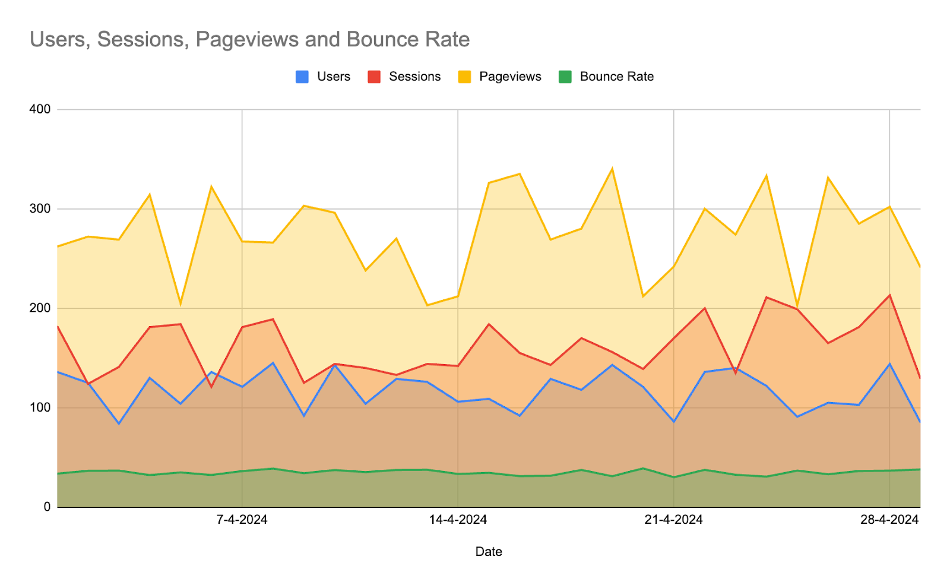
Keyword Rankings
Keyword | Position | Change
best coffee moorabbin | 1 | 0
cafe moorabbin | 2 | 0
coffee near me | 3 | +1
breakfast moorabbin | 4 | +2
latte art moorabbin | 5 | +3

User Profile Data

Date | User ID | Age | Gender | Location | Device type | Latitude | Longitude
1-4-2024 | 1001 | 25-34 | Male | Moorabbin, Melbourne | Mobile | -37.9011° S | 145.0972° E
1-4-2024 | 1002 | 35-44 | Female | Dingley Village, Melbourne | Mobile | -37.9286° S | 145.1333° E
1-4-2024 | 1003 | 18-24 | Male | Cheltenham, Melbourne | Tablet | -37.9136° S | 145.1239° E
1-4-2024 | 1004 | 45-54 | Female | Carrum Downs, Melbourne | Desktop | -37.9072° S | 145.0891° E
1-4-2024 | 1005 | 55-64 | Male | Oakleigh South, Melbourne | Mobile | -37.9000° S | 145.1467° E
2-4-2024 | 1006 | 25-34 | Female | Clayton, Melbourne | Tablet | -37.9100° S | 145.0300° E
2-4-2024 | 1007 | 35-44 | Male | Springvale, Melbourne | Mobile | -37.9217° S | 145.1111° E
2-4-2024 | 1008 | 18-24 | Female | Highett, Melbourne | Mobile | -37.9583° S | 145.0578° E
2-4-2024 | 1009 | 45-54 | Male | Sandringham, Melbourne | Mobile | -37.9100° S | 145.0300° E
2-4-2024 | 1010 | 55-64 | Female | Mentone, Melbourne | Tablet | -37.9333° S | 145.0750° E
3-4-2024 | 1011 | 18-24 | Male | Edithvale, Melbourne | Mobile | -37.8917° S | 145.0694° E
3-4-2024 | 1012 | 25-34 | Female | Chelsea, Melbourne | Mobile | -37.9072° S | 145.0891° E
3-4-2024 | 1013 | 35-44 | Male | Mordialloc, Melbourne | Tablet | -37.9167° S | 145.0917° E
3-4-2024 | 1014 | 45-54 | Female | Parkdale, Melbourne | Mobile | -37.8833° S | 145.0417° E
3-4-2024 | 1015 | 55-64 | Male | Patterson Lakes, Melbourne | Mobile | -37.9000° S | 145.0167° E
4-4-2024 | 1016 | 25-34 | Female | Heatherton, Melbourne | Tablet | -37.9681° S | 145.0833° E
4-4-2024 | 1017 | 35-44 | Male | Keysborough, Melbourne | Mobile | -37.9136° S | 145.1239° E
4-4-2024 | 1018 | 18-24 | Female | Cheltenham East, Melbourne | Mobile | -37.9167° S | 145.0917° E
4-4-2024 | 1019 | 45-54 | Male | Dandenong, Melbourne | Mobile | -37.8833° S | 145.0417° E
4-4-2024 | 1020 | 55-64 | Female | Dandenong North, Melbourne | Tablet | -37.9000° S | 145.0167° E
29-4-2024 | 1101 | 18-24 | Female | Bentleigh East, Melbourne | Mobile | -37.9011° S | 145.0972° E
29-4-2024 | 1102 | 45-54 | Male | Hampton, Melbourne | Desktop | -37.9286° S | 145.1333° E
29-4-2024 | 1103 | 55-64 | Female | Black Rock, Melbourne | Tablet | -37.9136° S | 145.1239° E

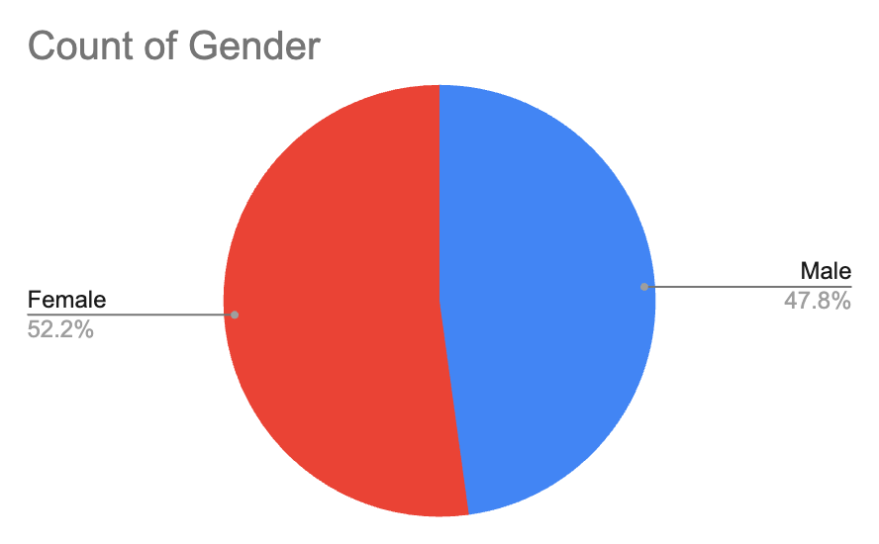

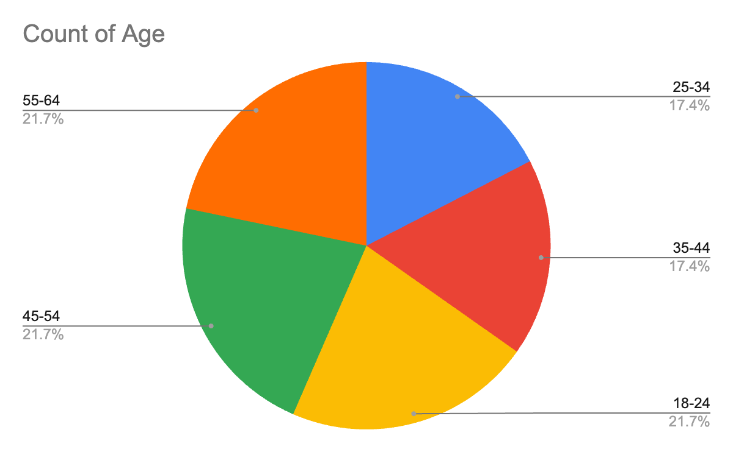

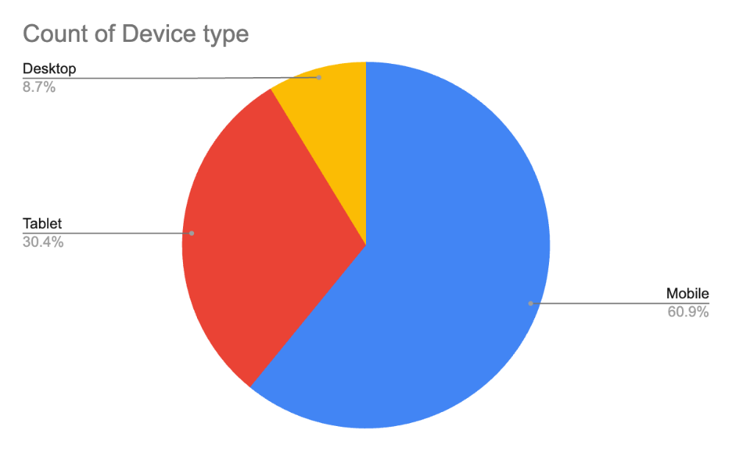

Question / Criteria |  |  | Answer/satisfactory response
1. CLIENT RECOMMENDATIONS REPORT

On review of the SEO Report, identify and recommend areas for improvement or potential opportunities for growth in relation to:
  - search engine optimisation;
  - search engine marketing; and
  - social network marketing.

You must provide TWO (2) recommendations for EACH of the methods listed above. Moreover, EACH of these recommendations must:
- state at least TWO (2) suggestions/opportunities for each method category;
- each category must include at least ONE (1) “implementation suggestion”, being an example of how the website’s code/structure could be adjusted; and
- each category must briefly assess the current state of its relevant marketing method; and
- your suggestions should refer to concepts such as keywords, keyword density, search terms and search engine rankings.
- Search engine optimisation |  |  | < Detail TWO opportunities for this strategy, ensuring you meet all the requirements >
- Search engine marketing |  |  | < Detail TWO opportunities for this strategy, ensuring you meet all the requirements >
- Social network marketing |  |  | < Detail TWO opportunities for this strategy, ensuring you meet all the requirements >
2. SEO ACTION PLAN:

Based on your analysis of the SEO Report, create a clear plan that The Coffee Movement could follow across the next 12 months, which reflect your recommendations above.

Complete the following five sub-questions, which will guide you through the necessary points needed to form this short-medium term SEO action plan:
- Set at least TWO (2) measurable goals for the set timeframe.  “What do you want to accomplish in the next 12 months?” |  |  | < Set TWO measurable goals to target in the timeframe >
- Identify at least FOUR (4) specific strategies to pursue.  “What actions will help you reach your goals in (a)” |  |  | < Identify FOUR specific actions to pursue to achieve the above goals>
- Re-order your strategies into a priority list.  “Which tasks are most important and should be completed first?” |  |  | < Re-order your list into a set of numbered priorities – the most important task should be first! >
- Create a schedule for completion of each strategy.  “When should each task be completed – set deadlines to keep you on track” |  |  | < Determine a scheduled completion date for each listed action >
- List at least TWO (2) roles that you could allocate responsibility of the actions to.  “Who will be responsible for each task? What type of web/marketing role could cover the actions determined” |  |  | < List at least THREE (3) types of web roles that could be allocated responsibility over these actions >
Sign Off
Assessment Documentation
You will need to organise with your facilitator to observe your presentation and demonstrate the following skills:
Skills to be observed during this task to the required standard.  Checklist (To be completed by the learner’s facilitator)  The following tasks are to be completed in relation to Part 6 – SEO Research and Analysis. Each of the skills must be observed on at least one occasion by the facilitator. |  |  |  |  |  | Satisfactory
 |  |  |  |  |  | Yes | No
- The learner has successfully met documentation & brief requirements, has presented their findings effectively, and has achieved sign off for their reports, ahead of Part 7 implementation. |  |  |  |  |  | ☐ | ☐
Assessor Name | Alex Bicknell | Assessor Signature |  | Signature | Date | Insert Date

Part 7 – Optimising the Live Website
Assessment Documentation

Optimise the Live Website for Search
Congratulations on successfully launching your website!
However – once a website has been launched and indexed on a search engine, it does not mean that it can be found effectively by your intended users. At this stage, you will need to develop, implement and monitor search engine optimisation strategies, in order to drive more traffic to your website.

Moreover, you will need to run a series of post-launch tests to check on other various performance metrics, which we initially analysed back in Part 4.

Important Note: Make sure to refer to the SEO strategy report you prepared and delivered in Assessment 1, as these covered a website in the same industry – your report’s findings should provide SEO implementation ideas for your developed website.
Question / Criteria |  |  | Answer/satisfactory response
SEARCH ENGINE OPTIMISATION
- Review your defined audience determined in Part 1 & your competitor SEO analysis from Assessment 1.  Based on this research, generate keyword suggestions for your website by:  - listing at least SIX (6) keywords your intended audience are likely to use when searching for items related to the client’s business; AND  - then sort & state which keywords are either broad keywords (“long-tail”) or specific sub-keywords (“short-tail”) (you must have at LEAST ONE (1) example of each type) |  |  | Long-tail Keywords
 |  |  | - < List your long-tail keywords here >
 |  |  | Short-tail Keywords
 |  |  | - < List your short-tail keywords here >
- Based on your understanding of SEO, your determined keywords & your audience analysis – identify THREE (3) SEO optimisation opportunities for your website.  Each opportunity should:  - State what webpage it will alter;  - Confirm at least ONE (1) long-tail & ONE (1) short-tail keyword to be incorporated; and  - Explain how at least ONE (1) web page element/section/content will incorporate these keywords to improve SEO performance.  REMINDER - SEO can be improved by updating:  - Headers – use keywords in headers;  - Content – incorporate keywords into your written content;  - Optimise images – include the keyword in image alt tags;  - Webpage – create a dedicated keyword webpage, that targets keywords & offers keyword information on it; and  - Blog posts – write articles about keyword topics, making sure to incorporate those same keywords into the content. |  |  | Optimisation Opportunity 1
 |  |  | < Identify and explain FIRST optimisation opportunity here, with all relevant details >
 |  |  | Optimisation Opportunity 2
 |  |  | < Identify and explain SECOND optimisation opportunity here, with all relevant details >
 |  |  | Optimisation Opportunity 3
 |  |  | < Identify and explain THIRD optimisation opportunity here, with all relevant details >
- Confirm that the website has incorporated the FIRST SEO opportunity listed in Question 1(b) above.  Insert ONE (1) code screenshot of keyword-enhanced element |  |  | < Insert ONE screenshot of Optimisation Implementation 1>
- Confirm that the website has incorporated the SECOND SEO opportunity listed in Question 1(b) above.  Insert ONE (1) code screenshot of keyword-enhanced element |  |  | < Insert ONE screenshot of Optimisation Implementation 2>
- Confirm that the website has incorporated the THIRD SEO opportunity listed in Question 1(b) above.  Insert ONE (1) code screenshot of keyword-enhanced element |  |  | < Insert ONE screenshot of Optimisation Implementation 3>
- To improve SEO rankings further, the website’s URL has been included as a back link on Brightspace, in “The Live Café Dashboard”.  Insert ONE (1) screenshot of your URL in the Dashboard to confirm the site has an active back link. |  |  | < Insert ONE (1) screenshot of website URL back linked in the Live Café Dashboard >
WEBSITE QUALITY ASSURANCE
- You reviewed your initial SEO position in Part 5, Questions 7 & 8.  Repeat similar tests & measure your updated SEO performance, by conducting the following:  - ONE (1) screenshot of a “site:” website search;  - ONE (1) screenshot of a “keyword” search, using one of your implemented keywords OR show the overall rankings using GSC Performance Average Position; and  - ONE (1) updated screenshot of your Google Analytics over-time traffic for at LEAST THREE (3) elapsed days.  Note: THREE (3) screenshots in total |  |  | Google :site Search
 |  |  | <Screenshot of Google “site:” search>
 |  |  | Google keyword search
<Screenshot of Google keyword search
OR
GSC Performance Average Position graph >

 |  |  | Updated Google Analytics output
 |  |  | <Screenshot of Google Analytics output>
- Summarise in ONE (1) paragraph your updated SEO’s performance & whether you improved either your site’s search rankings or traffic driven to your website.  Further, provide at least ONE (1) further suggestion of how you could improve your website’s SEO further. |  |  | Summary of SEO performance
 |  |  | < Summarise your second-round of SEO here >
 |  |  | Method to improve SEO further
 |  |  | < Record your suggested improvement here >
- On review of your development build performance test from Part 4, Question 4 – repeat your Google Lighthouse test and confirm the live technical performance measurements for your website  For this question:  - Insert ONE (1) screenshot of the Google Lighthouse output in desktop;  - confirm your live value for “Speed Index”; and  - state whether your performance is still within your performance budget from Part 4, Question 3 |  |  | < Insert screenshot of Google Lighthouse output >  - < State your new speed index >  - < State whether this is within the performance budget >
Sign Off
Assessment Documentation
You will need to organise with your facilitator to observe your presentation and demonstrate the following skills:
Skills to be observed during this task to the required standard.  Checklist (To be completed by the learner’s facilitator)  The following tasks are to be completed in relation to Part 7 – Optimising the Live Website. Each of the skills must be observed on at least one occasion by the facilitator. |  |  |  |  |  | Satisfactory
 |  |  |  |  |  | Yes | No
- The learner has conducted a comprehensive analysis of the websites SEO performance, provided optimisation suggestions and implemented changes to improve previous performance |  |  |  |  |  | ☐ | ☐
- The learner confirms that the hosting of the website on the selected web host is performing within client technical and security benchmarks |  |  |  |  |  | ☐ | ☐
Assessor Name | Alex Bicknell | Assessor Signature |  | Signature | Date | Insert Date

Part 8 – Client Sign Off
Assessment Documentation

Milestone Sign Offs
Prior to final sign off, you must enter the date of completion of prior Milestones & Builds relating to Part 4 and 8 – to be completed during the assessment period:
Milestone Checklist (To be completed by the learner’s facilitator) |  |  |  | Complete |  | Sign Off Date
- Milestone – Parts 1 to 4, Development Build |  |  |  | ☐ |  | ##.##.2025
- Final Build – Parts 5 to 8, Deployment & DevOps |  |  |  | ☐ |  | ##.##.2025
Ready for Final Sign Off & Submission
You are now able to present all working files along with this document to attain final sign off. On completion of final sign off, you will be able to submit this assessment and portfolio code.
Skills to be observed during this task to the required standard.  Checklist (To be completed by the learner’s facilitator)  The following tasks are to be completed in relation to the brief for this project. Each of the skills must be observed on at least one occasion. |  |  |  | Date 1 |  | Date 2
 |  |  |  | ##.##.2025 |  | ##.##.2025
 |  |  |  | Satisfactory |  | Satisfactory
 |  |  |  | Yes | No | Yes | No
- The project meets all applicable web standards & has been tested, debugged and documented according to user requirements and expected outcomes |  |  |  | ☐ | ☐ | ☐ | ☐
- The learner has analysed & benchmarked search, hosting and technical performance of the website in line with meet client requirements |  |  |  | ☐ | ☐ | ☐ | ☐
- The learner has obtained sign off from the client and confirmed business requirements are met |  |  |  | ☐ | ☐ | ☐ | ☐
Assessor Name | Alex Bicknell | Assessor Signature | Signature | Date |  | Insert Date

